Pension reforms: new governance arrangements
Purpose

For discussion and direction.

Summary

This paper sets out proposals for the approach FSMC might take up in respect of the new firefighter pension governance arrangements which will come into effect in April 2015.

Recommendation

Members are asked to consider the proposed approach to local pensions boards outlined in paragraphs 11 and the proposed principles for identifying LGA representatives for the Scheme Advisory Board set out in paragraph 17.

Action

Members will take action as directed.

Contact officer: | Eamon Lally
Position: | Senior Adviser
Phone no: | 02076643132/07799768570
Email: | eamon.lally@local.gov.uk

Pension reforms: new governance arrangements

Background

- A Proposed Final Agreement on the scheme design for the Firefighters’ Pension Scheme 2015 in England was published on 23 May 2012. The reformed firefighters’ pension scheme will come into force on 1 April 2015.

- As part of the reforms specific new governance arrangements are required. These arrangements will require greater involvement by elected members operating both at a national and local level.

- At its meeting on 10 March 2014, FSMC established a Pensions Working Group to look at the issue of governance arrangements in the reformed scheme and also to consider next steps in responding to the Government’s consultation response on retained pensions. The primary focus of the working group to date has been on the retained pensions issue, which is the subject of a separate agenda item. However, the working group considered that it was important for FSMC to consider an outline paper on pension governance at this time.

New governance arrangements

- Section 5 of the Public Service Pensions Act 2013 requires public service pension schemes to establish a pension board. The pension board will be required to assist the scheme manager in securing the effective and efficient governance and administration of the pension scheme and any statutory scheme connected with it, and ensure that they are operated to an appropriate standard. Pension boards will have oversight of the fire and rescue authorities’ administration of the Firefighters’ pension schemes 1992, 2006 and 2015. In addition the pension boards will ensure that schemes secure compliance with any requirements imposed by the Pensions Regulator, and will undertake any further matters as the scheme regulations may specify.

- The Public Service Pensions Act 2013 also specifies that scheme regulations must establish a Scheme Advisory Board.

- The arrangements for local pension boards and the Scheme Advisory Board will be consulted on later this year.

- The new governance arrangements are set out in Fig 1. Of particular interest to Members will be:

  - The work of the Scheme Advisory Board and the work of the Local Pension Boards

  - The composition of the boards and the appointment procedures

  - The training required for members in relation to their responsibilities as board members and how this might be delivered.

Fig 1: New Governance arrangements for the Firefighters Pension Scheme

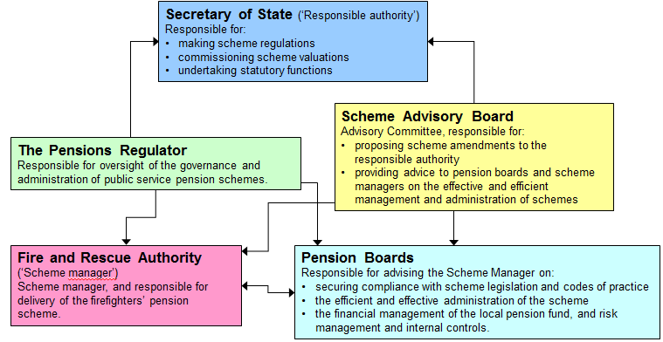

Local Pension Boards

- The Act requires that scheme regulations provide for the establishment of a board with responsibility for assisting the scheme manager in relation to:

  - Securing compliance with the scheme regulations, other legislation, and any requirements imposed by the Pensions Regulator

  - Any such other matters as the scheme regulations may specify.

- DCLG has made clear that under the Act there are a range of potential options for pension boards:

  - One board per scheme manager

  - Horizontal integration – for instance by geographical location, by administrative supplier

  - Vertical integration – combining with police/local authorities in a single area.

- The Act requires that the pension board must have equal numbers of ‘scheme member’ and ‘employer representatives’. Membership of the local pension boards will include elected councillors.

- The arrangements for Local Pension Boards will be a local matter to be determined in relation to individual local pension schemes. Under these circumstances FSMC might conclude that it does not need to advise on or seek to influence the design and implementation of Local Pension Boards, except to publicise the timescales and to consider the general point of training, which is considered later in this report.

Scheme Advisory Board

- The Scheme Advisory Board will have a key role in providing policy advice to the Secretary of State, at the Secretary of State’s request, on the desirability of changes to the scheme. The regulations may provide for the Scheme Advisory Board to provide advice to scheme managers or the scheme pension boards in relation to the management and administration of the firefighters’ pension schemes and the firefighters’ pension fund.

- Discussions on proposed terms of reference are ongoing between the LGA and Trade Unions and the objective is to achieve an outcome broadly in line with the governance arrangements for the Local Government Pension Scheme.. The composition of the Scheme Advisory Board will be established through these negotiations, but ultimately by regulation if no agreement can be reached. It is anticipated that an equal number of employee and employer representatives will be appointed. The Scheme Advisory Board is also expected to have an independent Chairman.

- The interest of employers in respect of the firefighter pensions is represented by the LGA, through the Fire Services Management Committee and currently through its membership of the Fire Pensions’ Committee (FPC), with the role being carried out by Cllr Maurice Heaster.

- The advent of the Scheme Advisory Board will see the FPC dissolved. As a result the LGA will need to exercise its role through the appointment of Councillors to the Scheme Advisory Board. It is likely that an increased number of councillors will be required to fill the positions on the Board.

- It is also anticipated that the Scheme Advisory Board will need to operate in shadow form prior to April 2015. This would require appointments to be made in the early autumn. It is expected that the costs of the Scheme Advisory Board will be funded through the employer contribution rate.

- FSMC is asked to consider and discuss the following principles for identifying councillor representatives for the Scheme Advisory Board:

  - The new employer positions on the Scheme Advisory Board will ideally be filled by councillors with some pension experience

  - Nominations should not be limited to FSMC members

  - Nominations for the new Scheme Advisory Board are considered at FSMC’s September meeting.

- In addition FSMC will want to ensure that the costs and resource requirements of the Scheme Advisory Board are managed effectively. One option would be for LGA to provide the secretariat function, but the ability of the LGA to do this would depend on capacity and funding arrangements.

Training

- Councillors participating in the new arrangements will need to receive some degree of training, particularly if they have not had any previous involvement in pension governance arrangements.

- It is anticipated that training will need to be jointly provided by the sector and DCLG. Training for LGA representatives on the Scheme Advisory Board will need to be provided in early autumn and LGA officers will work with officials from DCLG to establish a programme.

- It is anticipated that training for councillors who will sit on Local Pensions Boards will be delivered locally or sub-regionally, in order to reflect local design of the boards. It is expected that DCLG and LGA will provide support to local training of councillors as required.

Next steps

- Following the publication of the consultation on governance arrangements officers will update members on the options for taking the governance arrangements forward.

- Following decisions by FSMC officers will work to establish nominations for the Scheme Advisory Board.

- Following decisions by FSMC officers will work to establish a training programme for Scheme Advisory Board appointees.

